1)___Which of the following is considered a wilderness landscape?
a) Italian Gardens b) Central Park
c) Walden Pond d) The Rocky Mountains in the Western United States
e) all of the above
- b)
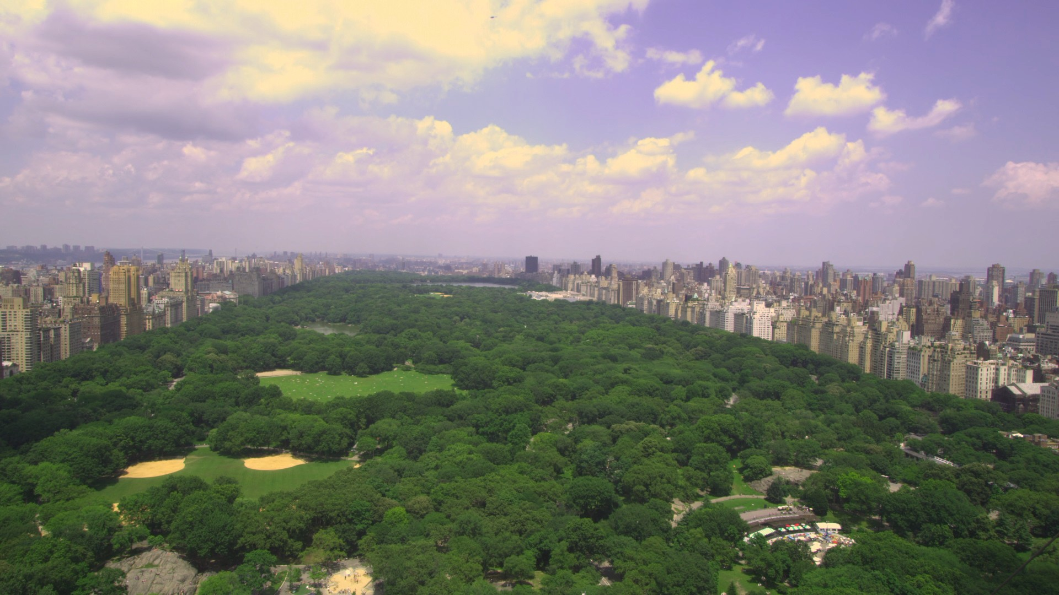
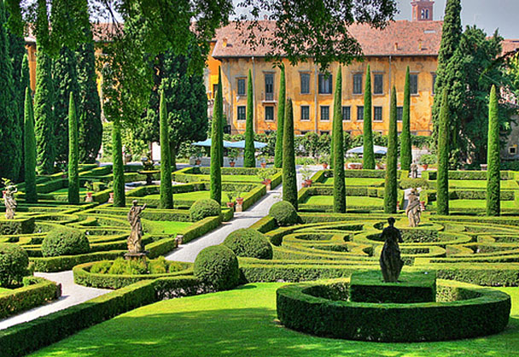

c). d)

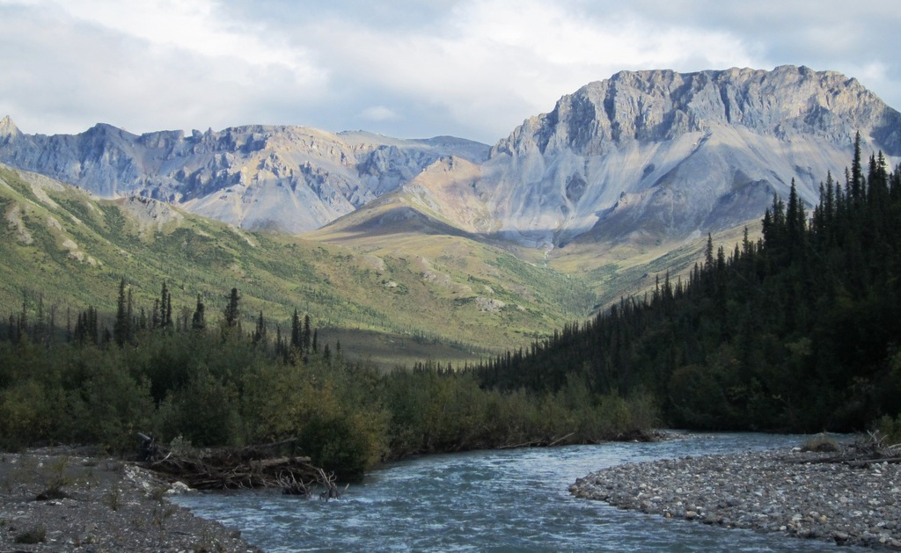
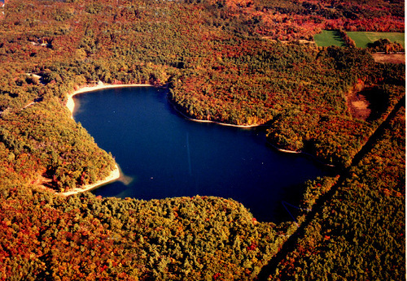

2) What is the definition of nature? Do you agree with this passage: “A thing is right when it tends to preserve the integrity, stability, and beauty of the biotic community? It is wrong when it tends otherwise.” Explain if or if not Thoreau is suggesting that the integrity of the biotic community supersedes the concerns for humans? Can wilderness also include when plants take over a city that was abandoned?

3) List one way Thoreau and Lewis and Clark differ in their viewpoints of nature and one way in which they are in common. Would they both be defenders of saving nature, would they both argue for preservation of natural landscapes? Did they study the environment and nature?

4)What is your definition of “wilderness”? Can it be considered wilderness when plants take over a city that has been abandoned by people? Explain.

5) Delineate between the human / nature relationships of﻿﻿﻿﻿﻿﻿ preservation, conservation and the exploitation of nature and a "do nothing" approach. Explain each perspective and link to an author. Where no author is linked to a protection of nature strategy﻿﻿﻿﻿﻿﻿﻿ just say﻿﻿﻿﻿﻿ so.﻿

6) What is the difference between the terms "natural", "nature", and "wilderness."﻿﻿﻿﻿﻿﻿﻿﻿﻿﻿﻿﻿﻿﻿
﻿
7)What is your definition of “wilderness”? Can it be considered wilderness when plants take over a city that has been abandoned by people? Explain.

